**IIT MANDI CS-207 APPLIED DATABASE PRACTICUM FALL 2018**

ASSIGNMENT 5: Understanding Cursors and Triggers

(In groups of 4-5 students containing B. Tech. 2nd years)

**Dr. Varun Dutt Due: Before 12:00 NOON on September 24th, 2018**

**Readings:**

* Class notes and slides from week 6
* Activity 6 on Moodle

**Objectives:**

* Understand how Cursors and Triggers works

**Submission:**

Each group will make one single submission.

Please submit as a zipped file, the following content:

1. A doc file containing the code and images of the **result table** (Please use the **limit** clause to only show the first 10 entries of the table)

**Assignment:**

Q1. In this question load the database from the dump file (join.sql) given in moodle

The Database has the following tables:

Customers: stores customer’s data.

Products: stores a list of scale model cars.

ProductLines: stores a list of product line categories.

Orders: stores sales orders placed by customers.

OrderDetails: stores sales order line items for each sales order.

Payments: stores payments made by customers based on their accounts.

Employees: stores all employee information as well as the organization structure such as who reports to whom.

Offices: stores sales office data.

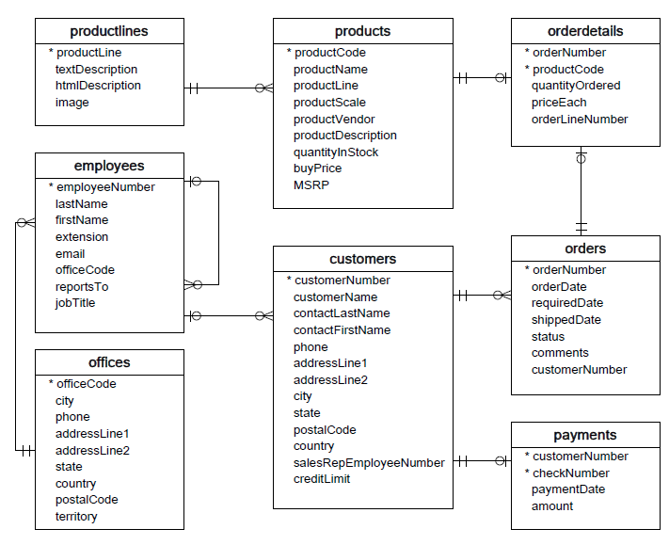

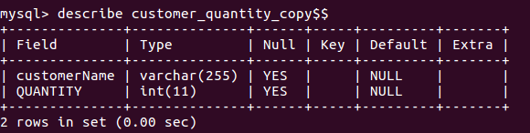Q1) Create a table named **customer_quantity_copy** with the following schema:

ii) Create a stored procedure that used a cursor that fetches the total orders (**orderdetails** table) placed by each customer (**customers** table) and store it in the **customer_quantity_copy** table.

Q2. Create a table named **employee_audit** thatkeeps track of any updation made to the **employees** table. The **employee_audit table** should have the following schema:

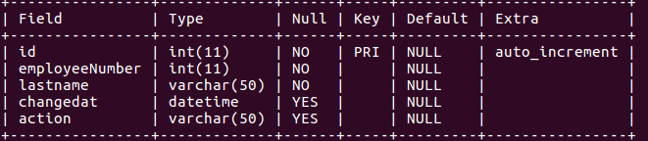

Create a BEFORE UPDATE trigger that is invoked before a change is made to the **employees** table. This trigger when invoked should insert into **employee_audit** the employeeNumber, Lastname of the employee and the time at which the record was updated into the **employees** table. Also SET action value to update

e.g if the below given query

**UPDATE employees SET lastName = 'Phan' WHERE employeeNumber = 1056;**

is executed. Then the employee_audit should contain the following values:

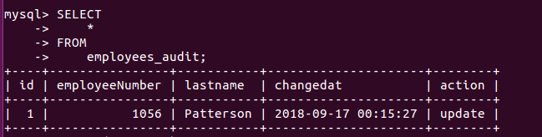

Q3. Load the dump file (dump.sql) from moodle.

The database is named **d1** and contains the following tables:

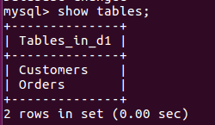

Create a table named **customer_audit** thatkeeps track of any row deletion made to the **Customers** table. The **customer_audit** table should have the following schema:

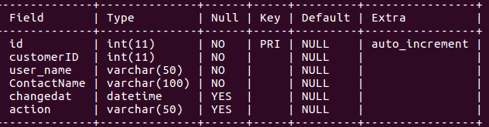

Create a AFTER DELETE trigger that is invoked after a record is deleted from the **Customers** table. This trigger when invoked should insert into **customer_audit** the CustomerID, Contact_name of the customer and the time at which the record was deleted from the Customerstable. The user who deleted the record should also be inserted into the **customers_audit** table. Also SET action value to **delete.**

if the below given query:

**DELETE from Customers where CustomerID=1;**

is executed. Then the **customer_audit** should contain the following values:

